Student Number [48793159](mailto:48793159@mylife.unisa.ac.za)

C0S 1511 Assignment 1

Introduction to Programming I

labious Goitsemodimo Phetoane

labiousphetoane@gmail.com

# Question 1

#include <iostream>

using namespace std;

int main(){

    /* number of people to serve factor */

    int mFactor;

    /* Quantity of ingredients */

    int quantity[7] = {4,250,1,2,1,150,4};

    /* ingredients */

    string  ingredients[7] = {"eggs","ml milk","teaspoon ground cinnamon","tablespoon caster sugar","teaspoon vanilla essence","g butter","slices bread"};

    /* method of making the toast */

    string method[4] = {"Place the eggs milk cinnamon sugar and vanilla essence in a bowl and whisk ",

                        "Heat a frying pan or the flat plate of a barbecue on lowest setting and melt the butter. soak each slice of bread in the egg mixture until wet through",

                        "Place the soaked bread in the pan or on the flat plate and cook until golden brown. turn and cook the other side. It is important to cook on a low to medium setting so the egg mixture cooks and sets rather than cooking on a higher heat which will burn the outside and leave the inside soggy."

                        ,"Once cooked transfer to a plate and serve with your choice of toppings or simply eat it on its own."};

    /* take an input from the user */

    cout << " FRENCH TOAST RECIPE : " << endl;

    cout << " How many people are you feeding : ";

    cin >> mFactor;

    //Create white space//

    cout << endl;

    cout << endl;

    cout << "Here are your Ingredients" << endl;

    /* Printing the table header */

    cout << " Quantity      " << "          Ingredient " << endl;

    //  Printing quantity elements

        for (int j = 0; j < 7; j++) {

            cout << " " << mFactor * quantity[j] / 2 << "   " << ingredients[j] << endl;

            cout << endl;

        }

    //Create white space//

        cout << " Please follow the following method to Prepare your serving"  << endl;

        cout << endl;

        /* Loop over the array and print*/

        for (int j = 0; j < 4; ++j) {

                cout << "Step " << (j + 1) << endl;

                cout << method[j] << endl;

                  cout << endl;

        }

    return 0;

}

Output

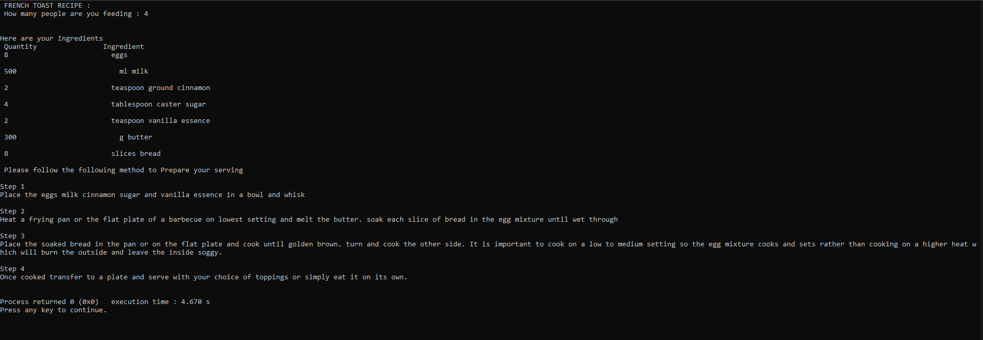

# Question 2

#include <iostream>

using namespace std;

int main(){

    /* • Declare three int variables */

    int nrGroups, nrLeft,groupSize;

    /* Innitialize number of students */

    int nrPupils = 56;

    /* Print the instructions for the input of student groups */

    cout << "Please enter the size of each group    : or press 0 to terminate the program : "<< endl;

    cout <<  endl;

    /* take the input for students */

    cin >> groupSize;

    cout << endl;

    /* Logic to calculate the remainder */

while (groupSize != 0) {

    cout << "There are  " << nrPupils / groupSize << " groups consisting of " << groupSize << " pupils." ;

    cout << endl;

    cout << endl;

    cout << "There are  "  << nrPupils % groupSize << " remaining pupils " << endl;

    break;

}

return 0;

}

Output

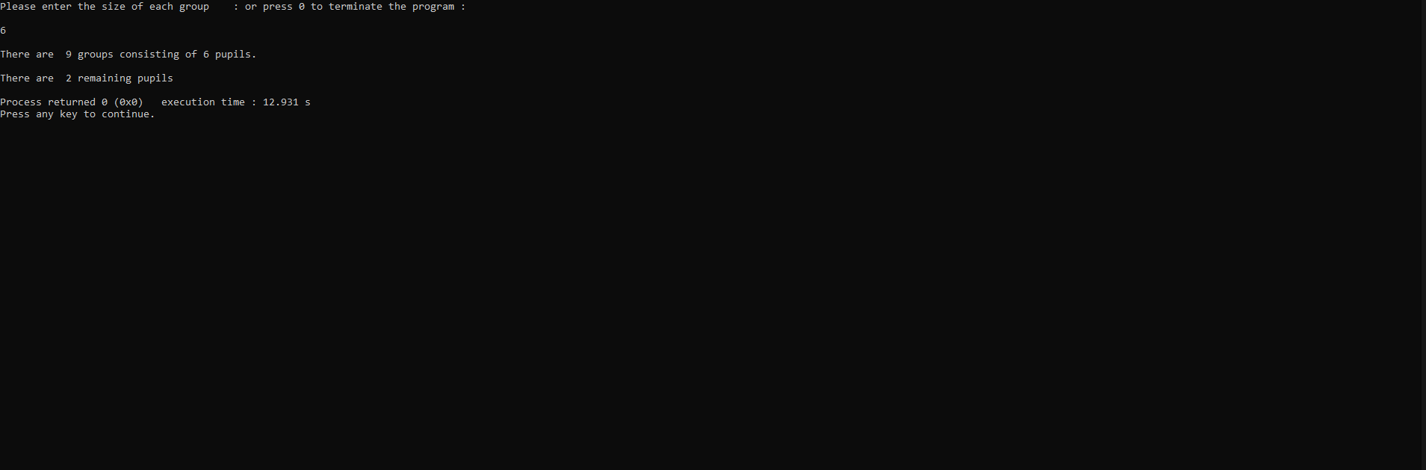

# Question 3

#include <iostream>

#include <iomanip>

using namespace std;

int main() {

    /* declare first, second as float*/

    float first, second;

    string operation;

    /* Print instructions for first input */

    cout << "Please enter the first float value : "<<endl;

    cin >> first;

   /* Print instructions for second input */

    cout << "Please enter the second float value : "<<endl;

    cin >> second;

       /* Print instructions for operation input */

    cout << "Please enter the character for the operation:"<<endl;

    cin >> operation;

    /* Logic to do calculations */

    if (operation == "+"){

        cout << "The sum of " << first << " and " << second << " is equal to : ";

        cout<<setprecision(2)<<fixed << first + second <<endl;

    }

    else if (operation == "-"){

        cout << "The difference between " << first << " and " << second << " is equal to : ";

        cout<<setprecision(2)<<fixed << first - second <<endl;

    }

    else if (operation == "*"){

        cout << "The product of " << first << " and " << second << " is equal to: ";

        cout<<setprecision(2)<<fixed << first * second <<endl;

    }

    else {

        cout << "The remainder between" << first << " and " << second << " is equal to : " ;

        cout<<setprecision(2)<<fixed << first / second <<endl;

    }

    return 0;

}

Output

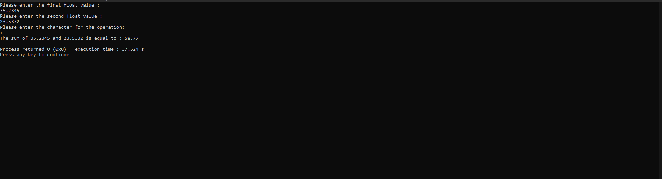

# Question 4

#include <iostream>

using namespace std;

int main() {

/* declare the two integer variables*/

int programsDone, result, average;

/* Logic to add result*/

    while (average < 50 ) {

        programsDone++;

        cout << "Please enter the result of program number " << programsDone << endl;

        cin >> result;

        average = (average + result)/programsDone;

    }

    return 0;

}

Output

# Question 5

#include <iostream>

using namespace std;

int main(){

    int n;

    int i = 1;

    //Take input from the user

    cout << "Enter a number to see all squares : ";

    cin >> n;

    //square until input is reached.

    while (i <= n) {

        cout << i * i ;

        i++;

    }

    return 0;

}

Output

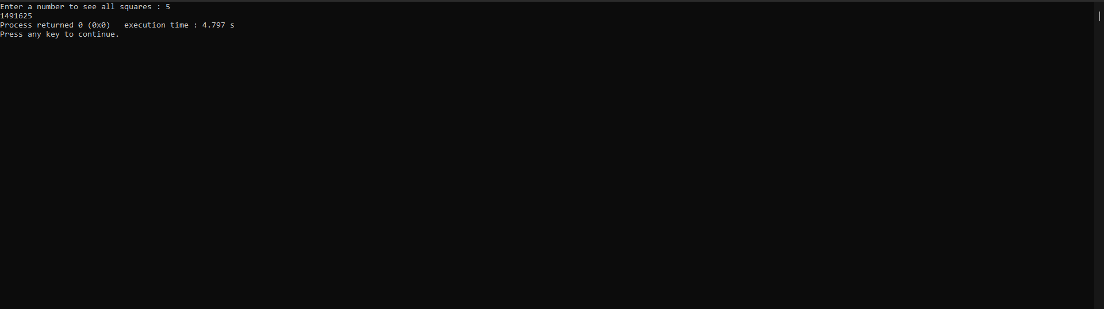

# Question 6

#include <iostream>

using namespace std;

int main(){

    float amount,discount;

    char customerType;

    cout << " Please enter the purchase total : " << endl;

    cin >> amount;

    cout << " Please enter a  customer type : 'S' for (student) 'D' (dealer) 'P' (pensioner) or'O'(other)" << endl;

    cin >> customerType;

    switch(customerType){

        case 'S':

        cout << "Your Student Discount is : R" << amount * 0.1 << " Your total is : R" << amount - amount * 0.1 << endl;

        break;

        case 'D':

        cout << "Your Dealer Discount is : R" << amount * 0.12 << " Your total is : R" << amount - amount * 0.12 << endl;

        case 'P':

        cout << "Your Pensioner Discount is : R" << amount * 0.15 << " Your total is : R" << amount - amount * 0.15 << endl;

        break;

        default:

        if (amount < 200){

               cout << "Your do not have a Discount" << " Your total is : " << amount << endl;

        }

        else {

        cout << "Your Student Discount is : R" << amount * 0.1 << " Your total is : R" << amount - amount * 0.1 << endl;

        }

    }

return 0;

}

Output

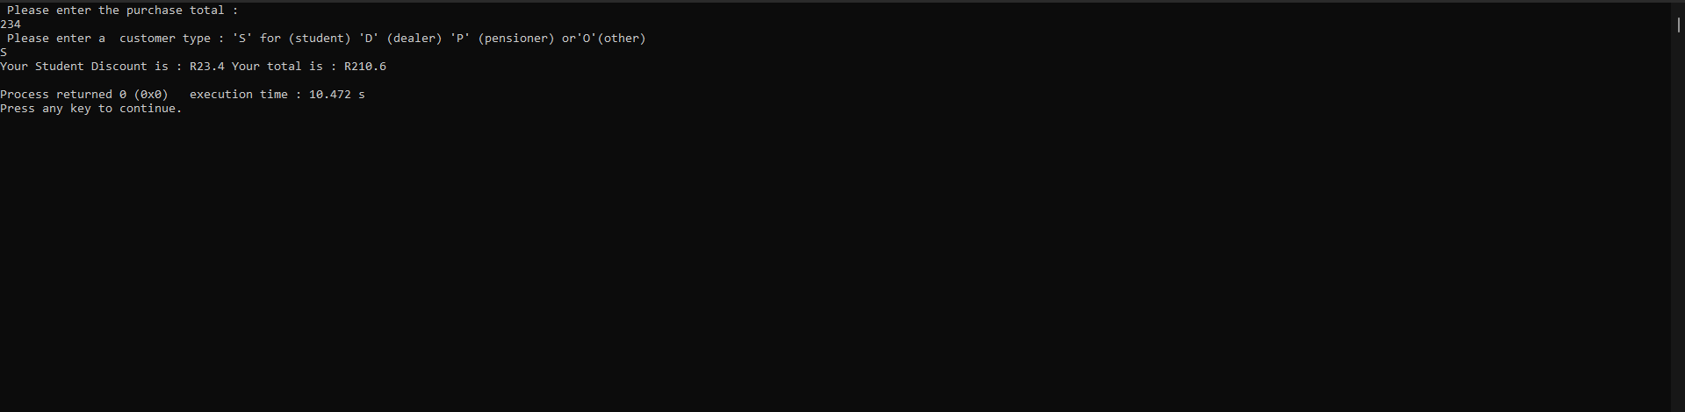

# Question 7

#include <iostream>

using namespace std;

int main(){

    int x = 0;

    while (x < 10 ){

        x = x + 2;

        cout << x << endl;

        }

    return 0;

}

# Question 8

#include <iostream>

using namespace std;

int main()

{

    int numberOfItems;

    int count; //loop counter for the loop

    int caloriesForItem = 0;

    int totalCalories = 0;

    cout << "How many items did you eat today? ";

    cin >> numberOfItems;

    cout << "Enter the number of calories in each of the " << numberOfItems << " items eaten: " << endl;

/*     While loop version

        while (count < numberOfItems){

        cin >> caloriesForItem;

        totalCalories += caloriesForItem;

        count++;

    } */

    for (int i = 0; i < numberOfItems;i++){

        cin >> caloriesForItem;

        totalCalories += caloriesForItem;

    }

    cout << "Total calories eaten today = " << totalCalories;

    return 0;

}

Output

